**Quiz 2**

CREATE TABLE books(

id int PRIMARY KEY,

name varchar(100) NOT NULL,

author varchar(50) NOT null,

price int,

is_publish boolean

);

INSERT INTO books VALUES(1, 'The Intelligent Investor', 'Benjamin Graham', '175500', 'true');

INSERT INTO books VALUES(2, 'Segala Galanya Amyar', 'Mark Manson', '111000', 'false');

INSERT INTO books VALUES(3, 'Rich Dad Poor Dad', 'Robert T.Kiyosaki', '54400', 'false');

INSERT INTO books VALUES(4, 'Novel Bulan', 'Tere Liye', '76000', 'true');

INSERT INTO books VALUES(5, 'You Do You', 'Fellexandro Ruby', '102400', 'true');

INSERT INTO books VALUES(6, 'Start with Why', 'Simon Sinek', '80000', 'false');

select name, author, price from books;

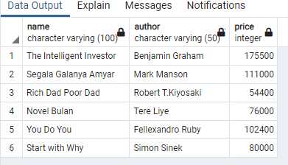

select * from books where price >= 80000;

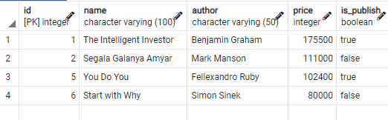

select * from books where name like 'rich%';

update books set price = '180000', is_publish = 'true' where author = 'Simon Sinek';

delete from books where name = 'Novel Bulan';

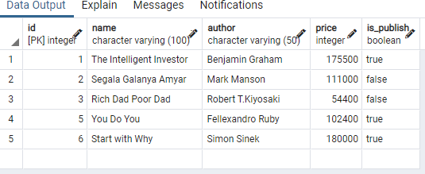

select * from books order by price asc;

